***Introduction***

The hand-powered Antikythera machine, the first analog computer, predicted astronomical positions and eclipses decades in advance. It was also valuable for tracking the four-year cycle of athletic games, which matched the Olympiad.

This relic was unearthed off Antikythera, a Greek island, in 1901. Valerios Stais found it on May 17, 1902. The gadget was initially found as a single mass was deconstructed into three components and is now fractured into 82 shards. It was housed in the ruins of a wooden-framed box with (uncertain) total dimensions of 34 cm 18 cm 9 cm (13.4 in 7.1 in 3.5 in). Many of the items feature inscriptions and gears. The largest gear has 223 teeth and a 13-cm diameter.

Cardiff University academics Mike Edmunds and Tony Freeth used computer x-ray tomography and high-resolution surface scanning in 2008 to look into the crust-encased device and understand its inscriptions. It has 37 bronze gears that mesh together to watch the Moon and Sun as they go around the zodiac, forecast eclipses, and imitate the Moon's anomalous orbit in which its perigee velocity is larger than its apogee velocity. Hipparchus of Rhodes, a second-century BC astronomer, studied this motion and may have been consulted. A missing element has led to significant speculation over whether the approach established the positions of the five classical planets.

The device has been created by Greek scientists about 87 BC or between 150 and 100 BC or to 205 BC. It had to be constructed before the shipwreck, which is dated to 70–60 BC. In 2022, researchers estimated the machine's initial calibration date was December 23, 178 BC. Some experts believe that the calibration date should be 204 BC. Up to the astronomical clocks of Richard of Wallingford and Giovanni de' Dondi in the fourteenth century, comparable complicated machines had not been seen.

The National Archaeological Museum in Athens has the sole intact components of the Antikythera mechanism and several artistic recreations of how it may have looked and worked ("Antikythera mechanism - Wikipedia", 2022, Introduction Section).

As always, I'm excited to have you back for another exciting episode of ____, where we explore the wonders of our everyday lives. We'll be delving into a subject that has evolved into a cutting-edge technological form and had widespread practical use throughout the years.

There are many mysteries to unravel surrounding the Antikythera mechanism, but let's take a look at where current science stands on the matter.

***What is the Antikythera mechanism and why is it a mystery?***

The following info reveals what the Antikythera mechanism is and its mysteries (Killgrove, 2016):

1. The Antikythera mechanism was unearthed in a Roman shipwreck and named after a Greek island.

Antikythera means "opposite of Kythera" and is located in the Aegean Sea between Greece and Crete. The Roman ship sunk off the island's shore in the 1st century BCE, carrying relics from the 4th century BCE.

2. The initial investigation of the Antikythera wreck killed or wounded three divers.

In 1900, Greek sponge divers uncovered the wreckage using canvas suits and copper helmets. When the initial diver emerged with accounts of artifacts, horses, and bodies, the captain concluded he had "raptures of the deep"—an intoxication from the nitrogen in the breathing mix fed into the diving helmet. This diver was OK, but further exploration in 1901 killed one and disabled two from decompression sickness or "the bends."

3. Three Romans may have helped move the Antikythera mechanism.

Xenophon Moussas, an astrophysicist at Athens University, postulated in 2006 that the boat on which the mechanism was discovered may have been traveling to Rome in the 1st century BCE. A similar story suggests the ship was transporting treasure from Sulla's sack of Athens in 87–86 BCE. Marcus Tullius Cicero described a mechanical planetarium called a "sphere of Archimedes" that showed how the sun, moon, and planets moved relative to the Earth. New analysis reveals the ship was headed to Rome from Turkey. Because the Aegean was a bustling maritime region at the time, the ship's journey is hard to track.

4. It took 75 years to understand the Antikythera mechanism.

In 1900, a shipload of marble, coins, glassware, and ceramics included the bronze-and-wood artifact. The mechanism was neglected until 1951 because other artifacts seemed more important. Derek de Solla Price published the initial analysis of the Antikythera mechanism in 1974. Price died in 1983 without knowing how the gadget operated.

The Antikythera mechanism is in 82 parts, representing a third of the original. In 2021, University College London researchers scanned the shards, examined the symbols and inscriptions, and matched this information to what ancient Greeks knew about astronomy and time to model the machine's gears. Scientific Reports reported the findings, although it's unclear whether the ancient builders possessed the ability to build it this way.

5. The Antikythera device attracted Jacques Cousteau and Richard Feynman.

Jacques Cousteau and his colleagues dove the Antikythera shipwreck in 1976, soon after Price's publication, and found 1st-century BCE coins and bronze mechanism components. Richard Feynman subsequently visited Athens' National Museum. Feynman was allegedly dissatisfied by the museum overall but remarked that the Antikythera mechanism was "so unusual and bizarre that it is practically impossible... It's a contraption with gear trains, like a contemporary alarm clock."

6. The Antikythera mechanism is considered the first computer.

Before digital computers, there were analog ones. These computers vary from slide rules to tide-predicting devices. The Antikythera device was supposed to calculate dates and forecast astronomical occurrences.

7. Trigonometry's creator may have constructed the Antikythera device.

Hipparchus was born in Turkey in about 190 BCE and taught in Rhodes. Later Greek and Roman writers preserved his writings. Hipparchus was one of the first to suppose the Earth rotated around the sun, but he couldn't prove it. Hipparchus, the creator of trigonometry, constructed the first trigonometric table to solve spherical issues. The Antikythera mechanism is commonly assigned to Hipparchus because of his previous discoveries and because Cicero cites a planetary device built by Posidonius, who took over Hipparchus' school on Rhodes following his death. A new study shows two separate handwritings on the mechanism, indicating it was made in a workshop or family company.

8. Nothing topped the Antikythera mechanism for 1500 years.

The clockwork system had at least 30 bronze gears in a shoebox-sized wooden box. A hand-crank may shift time forward or backward. The crank turned gears that displayed Greek zodiac signs and Egyptian calendar days. The knowledge to manufacture such a gadget may have been lost over time since it was a specialty device or pricey. In Europe, astronomical clocks reappeared in the 14th century. Many experts believe that we may identify ancient predecessors to this technology in an archaeological environment.

9. The Antikythera mechanism tracked celestial occurrences, seasons, and festivals.

The device monitored the moon's location and phase and predicted eclipses. It monitored seasons and celebrations like the Olympics. The calendar is based on the period between full moons, and a particular clock showed the seasons, which was beneficial for agriculture. The creator of the Antikythera device includes two dials that spin to indicate lunar and solar eclipses. The mechanism's most advanced function was calculating the moon's period and elliptical orbit.

10. Antikythera features a built-in manual.

Writing on a bronze plaque behind the mechanism implies the creator left instructions or an explanation. The Koine Greek inscription describes the mechanism's cycles, dials, and operations. The literature doesn't explain how to use it and presupposes some astronomical expertise, but it names the mechanism.

11. No one knows who utilized Antikythera.

Many of its capabilities are known, but its usage is unclear. Scholars believe it was used in a temple or school, although it might have been a wealthy family's curio. We don't know who used this thing or why without accompanying artifacts or inscriptions.

12. Archaeologists are closing near the Antikythera mechanism's location.

The usage of Koine in several inscriptions puts the mechanism's invention in the then-vast Greek realm. The festival dial cites the Olympics, Naa, and Halieia on Rhodes. Alexander Jones and colleagues found in 2016 that the system could monitor 42 calendar events. Jones and colleagues estimate that the mechanism's originator was about 35°N latitude. With Cicero's reference to a comparable device at Posidonius' school, Rhodes is again the dominant candidate for the mechanism's origin.

13. Antikythera's device told fortunes.

Jones and colleagues based their new interpretation on the device's 3400 Greek characters, however, thousands more are presumably missing owing to the artifact's incompleteness. Their language study revealed that the mechanism alludes to eclipse hue, size, and winds. Greeks felt eclipse features were good and evil omens. By adding predicting eclipse technology, the inventor allowed the user to discern the future.

14. The Antikythera machine accurately predicted planetary motion for 500 years.

The mechanism featured hands or pointers for Mercury, Venus, Mars, Jupiter, and Saturn, all plainly visible in the sky, plus a revolving ball that depicted moon phases. Text on the mechanism's front plate reveals, according to Jones and his colleagues, that the planetary motion was represented mathematically using sophisticated gears—and was correct.

15. Do Two Antikythera shipwrecks exist?

Since Cousteau examined the site in the mid-1970s, little work has been done due to its remoteness and depth. In 2012, Woods Hole Oceanographic Institute and the Hellenic Ephorate of Underwater Antiquities dived the wreck using high-tech diving gear. They discovered amphorae and other items. Either the Roman ship was much bigger than imagined or there was another disaster. New items have been unearthed for years.

***Who discovered the mechanism and how?***

Captain Dimitrios Kontos ( v) and sponge divers from Symi found the Antikythera shipwreck in 1900 and retrieved artifacts in 1900–01. This Roman cargo ship was unearthed 45 meters (148 feet) off Antikythera's Point Glyphadia. The crew found bronze and marble sculptures, ceramics, unusual glassware, jewelry, coins, and the mechanism. The mechanism was recovered in July 1901. It's unknown how the mechanism got aboard the ship, but it may have been brought from Rhodes to Rome with other plundered goods for Julius Caesar's triumphant procession.

All debris objects were stored and analyzed at the National Museum of Archaeology in Athens. The mechanism looked like tarnished bronze and wood, so it remained undiscovered for two years while museum employees worked on sculptures. The mechanism deformed when removed from saltwater without treatment.

Valerios Stais discovered a gear wheel in a rock on May 17, 1902. He thought it was an astronomical clock, but other experts judged it too intricate to have been built at the same time as the other components. Derek J. de Solla Price, a scientific historian at Yale, reopened the investigation in 1951. Price and Greek nuclear scientist Charalampos Karakalos scanned 82 pieces in 1971. 1974's Price report was 70 pages long.

Two more searches at the Antikythera wreck site in 2012 and 2015 uncovered art artifacts and a second ship that may or may not be related to the treasure ship where the mechanism was located.

A bull-shaped bronze disc was also unearthed. Some claimed the disc's four "ears" with holes were a "cogwheel" for the Antikythera mechanism. There's little indication that it was part of the machinery; it was probably a bronze adornment on furniture ("Antikythera mechanism - Wikipedia", 2022, Discovery Section).

***How did the computer work?***

Ancient Greeks constructed a complicated analog computer to forecast lunar and solar eclipses, moon phases, and planet and sun movements around the zodiac. The Antikythera mechanism was unearthed in a shipwreck off Antikythera about 70 B.C. It was developed circa 150 to 100 B.C., maybe on Rhodes by astronomers and engineers.

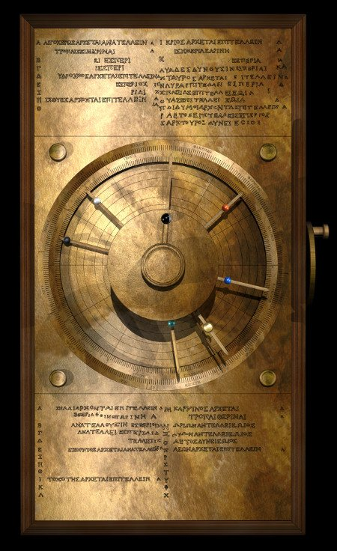

**Computer-generated conjectural model of the Antikythera mechanism. Credit: Tony Freeth and Alexander Jones.**

The device has sophisticated components like 18th-century clocks. The device's building knowledge was lost for centuries. Its technical intricacy wasn't seen again for a century, until medieval cathedral clocks(Olson, 2022).

**Simulated Cosmos**

The Antikythera mechanism was in a 340x180x90mm wooden box. Front and rear bronze plaques describe the device's geocentric cosmology. Inscriptions above and below the primary dials indicated star arrival and departure dates. The central exhibit included spheres symbolizing the Sun, Moon, and five planets known to the Greeks. Radial placements on pointer pins showed orbital distances. Revolving pointers crossed the zodiac and Egyptian calendar rings. So, celestial bodies' locations might be established during certain times of the year.

The whole mechanism was hand-cranked from the box's side. This input drove the gearbox. The impressively precise system included 40 gears ranging from 1.0 to 2.7 mm thick. Layers of gears have 1.4 mm gaps between them. These gears computed the dial outputs(Olson, 2022).

**Planetary and Solar Mechanisms**

Antikythera mechanism pieces are not complete. Various variations of the gadget were created to fill the gaps. In Tony Freeth and Alexander Jones' model, the instrument included many gear modules for each notion. These include eclipse, solar anomaly, inferior and superior planets.

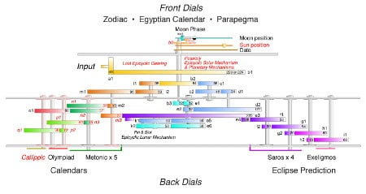

**Schematic gear diagram of the Antikythera Mechanism. Physical evidence exists for gears labeled in black text. Gears labeled with red text are conjectural. Credit: Tony Freeth and Alexander Jones.**

The mechanism models planetary and solar movements using Greek deferent and epicycle ideas. Using epicyclic gearing, where one gear's center spins around another's, helps translate this theory into practice. Freeth and Jones explain the planetary mechanism's function.

A gear is spun at the deferent rate, while a second gear is turned at the epicycle rate. A slotted follower follows an epicyclic gear pin on a different axis. A tube connects the follower to a pointer. Variable motion is produced(Olson, 2022).

**Engineering Expertise**

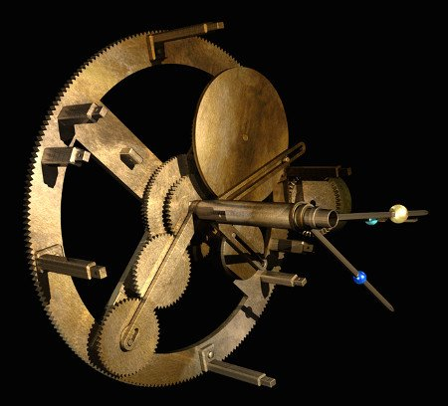

The solar and inferior planet mechanisms. Credit: Tony Freeth and Alexander Jones

The Antikythera Mechanism's sophistication shows it was part of a centuries-old technical history. The Antikythera mechanism requires pin-and-slot and epicyclic gearing expertise to work. Component fabrication required extraordinary accuracy. Hand equipment such as files, drills, lathes, hammers, pliers, rulers, and dividers was used to make gears to tenths of a millimeter accuracy.

The Antikythera device demonstrates advanced engineering. This knowledge being forgotten for millennia is a quirk of human history. Imagine if knowledge was kept and expanded. What marvels may ancient academics and engineers have invented centuries before they appeared?

The National Archaeological Museum in Athens, Greece, displays the Antikythera mechanism's surviving pieces and entire copies(Olson, 2022).

***Who do we think designed the mechanism?***

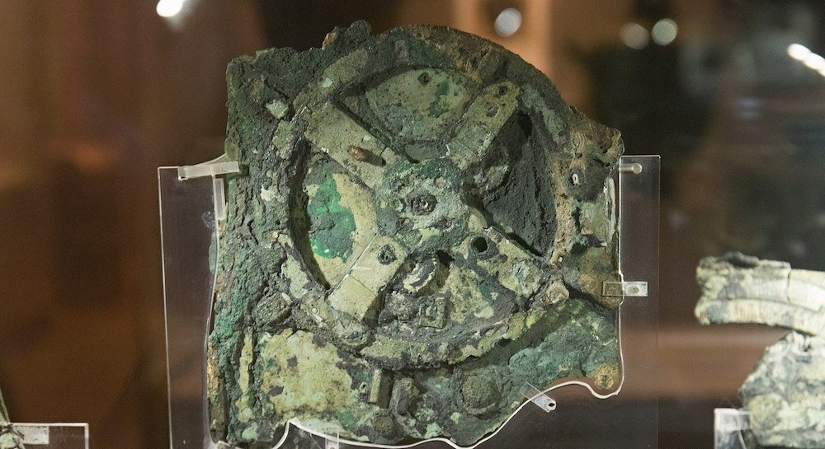

*The Antikythera Mechanism is currently housed at the National Archaeological Museum. Credit: ZDE/Wikimedia Commons/CC BY-SA 4.0*

According to British and Greek experts, the Antikythera Mechanism, humanity's first computer, was developed by Archimedes.

A team of experts at University College London (UCL) thinks the famous ancient Greek mathematician developed a sophisticated device, which calculated and depicted the movement of the stars across the skies.

Mathematician and filmmaker Tony Freeth of the UCL Research Team, which includes Myrto Georgakopoulou and Aris Dakanalis, believes Archimedes was behind humanity's first computer.

If Archimedes of Syracuse, the "Leonardo da Vinci of antiquity," invented it, it dates between 287 BC to 212 BC, his known life span. In 1901, the Antikythera Mechanism was found. The ancient Greek invention is considered the world's the first computer.

Greek sponge divers found the Antikythera Mechanism in 1901. Multiple studies put its construction between 150 BC and 100 BC. Later research put it around 205 BC, seven years after Archimedes' death.



Freeth and his crew think Archimedes invented the Mechanism.

Since then, historians and scientists have been unable to reassemble the object's 82 parts. This bronze shoebox-sized device tracks the planets and stars using gears.

Freeth and his colleagues issued a study in March 2021 proposing a new explanation for the front gearing. Scientific American published Freeth's research this month.

The device's brilliance defies many of our notions about ancient Greek technology.



*Marine archaeologists investigating the site of the Antikythera shipwreck. Credit: Greek Ministry of Culture*

Freeth credits Derek J. de Solla Price, who authored "Gears from the Greeks" in 1974, with citing Cicero's 106–43 B.C. description of Archimedes' machine.

Cicero stated the mechanism "delineated the movements of the sun, moon, and the five wandering stars"

Archimedes devised a means to appropriately show divergent motions with varied speeds on a single globe.

This contraption sounds like the Antikythera mechanism, Freeth writes. Archimedes, who lived before the gadget was developed, may have started the tradition that led to it. Archimedes' invention may have inspired the Antikythera mechanism.

Price and Charalambos Karakalos identified 30 gears: 27 in the biggest component and one in three others. According to Freeth, the 223-tooth gear spins extremely slowly to move the saros dial pointer. Calculating the epicyclic theory of the moon using epicyclic pin-and-slot gears was an astonishing invention by the ancient Greeks and this inventiveness suggests Archimedes developed the mechanism.

Antikythera is unlike any ancient device. According to Freeth, there’s uncertainty whether anyone knows why the technology was lost and then redeveloped; history is incomplete, and future discoveries may surprise us. The Antikythera mechanism is not the conclusion of their narrative. They feel their work is a huge achievement, but there are still puzzles to unravel. The UCL Antikythera Research Team isn't sure their reconstruction is valid due to evidence loss. It's difficult to match all remaining data. We can see more clearly than ever how impressive this thing is ("Antikythera Mechanism Designed by Archimedes, Say Experts", 2022).

***Summation***

Antikythera Mechanism predicted solar eclipses and structured the Olympiad calendar in four-year cycles. The mechanism arose in Corinth's colonies in Italy, perhaps Syracuse, Sicily. Scientists cited a link to Archimedes. Archimedes developed a planetarium and wrote a forgotten treatise on astronomy. Evidence linked the gears and dials to Rhodes and Hipparchos, who examined lunar orbit anomalies. The Antikythera Mechanism was unearthed in a shipwreck north of Crete. Invented between 140 and 100 B.C. Scientists can read inscriptions and repair gears using high-resolution images and 3D X-ray tomography. Recent research found all 12 ancient months on the instrument's back. Tony Freeth, the founder of the Antikythera Mechanism Research Project in Cardiff, Wales, said the month names "are unexpected of Corinthian origin," indicating "a history extending back to Archimedes." Metonic calendar lacked month names. This calendar and other details indicated Greek influence from Babylonian astronomy. Babylonians used the calendar about 500 B.C. Freeth, linked with the production company London's Images First, stated the Metonic calendar reconciles the lunar month and solar year. Twelve lunar months are 11 days short of a year, but 235 fit into 19 solar years, and a mathematical calendar can synchronize with the sun and moon. Metonic dates Jewish and Christian festivals. The mechanism's connection to Kos, Rhodes, and Pergamon was astonishing. The instrument's months "match" Illyrian, Epirian, and Corfu calendars. Seven months suggests a Syracuse connection. One of the instrument's dials was used to record the pan-Hellenic games' four-year cycle, a Greek "chronological framework.". Freeth thinks the mechanism's leftover gears and star almanac are puzzling. The Antikythera Mechanism's function in Greek technology is uncertain. Freeth says this clever and intricate mechanism can't be the first. They can't fathom why this amazing technology disappeared for hundreds of years, only to reappear in the massive astronomical clocks of the 14th century and afterward (Noble Wilford, 2008).

**References:**

1. Antikythera mechanism - Wikipedia. En.wikipedia.org. (2022). Retrieved 19 September 2022, from <https://en.wikipedia.org/wiki/Antikythera_mechanism>.
2. Killgrove, K. (2016). *15 Intriguing Facts About the Antikythera Mechanism*. Mental Floss. Retrieved 18 September 2022, from <https://www.mentalfloss.com/article/81445/15-intriguing-facts-about-antikythera-mechanism>.
3. Olson, E. (2022). How the Antikythera Mechanism Works. Engineering360. Retrieved 19 September 2022, from <https://insights.globalspec.com/article/5158/how-the-antikythera-mechanism-works>.
4. *Antikythera Mechanism Designed by Archimedes, Say Experts*. Greek Reporter. (2022). Retrieved 19 September 2022, from <https://greekreporter.com/2022/02/11/antikythera-mechanism-archimedes/>.
5. Noble Wilford, J. (2008). *Mysteries in the Antikythera Mechanism (Published 2008)*. Nytimes.com. Retrieved 19 September 2022, from <https://www.nytimes.com/2008/07/31/world/europe/31iht-computer.1.14907195.html>.

|--------------------------------------------------| The End|-------------------------------------------------|